Smartphones
# Source: AI Source: Provided by: [Data Path: Persons Table -> ID Column: 1, Name_En Column: Motasem Essam] -> From: [ChatGPT] on [1/23/2026]
A smartphone is a mobile device that combines the functionality of a cell phone with the features of a computer. It allows you to make calls, send text messages, and access the internet, along with running a wide range of applications (apps) for communication, entertainment, productivity, and more.

Smartphones Image
# Source: ScreenShots Source: Provided by: [Persons Table -> ID Column: 1, Name_En Column: Motasem Essam] -> Tool: [Lightshot Program] -> From [Site: Google Search: Images: Smartphones] on [1/23/2026]
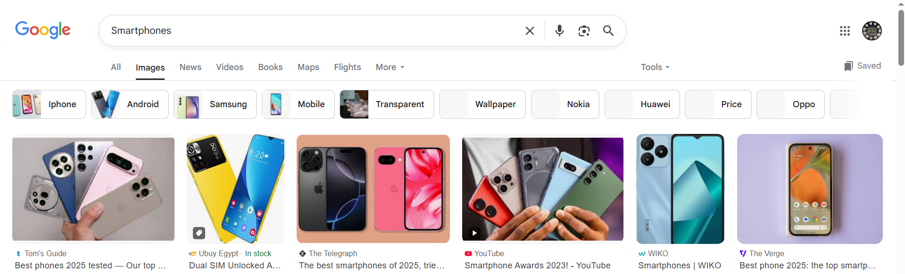

🔑 Key Features of Smartphones:
# Source: AI Source: Provided by: [Data Path: Persons Table -> ID Column: 1, Name_En Column: Motasem Essam] -> From: [ChatGPT] on [1/23/2026]
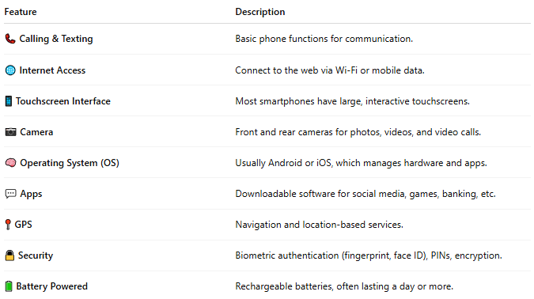

Feature | Description
📞 Calling & Texting | Basic phone functions for communication.
🌐 Internet Access | Connect to the web via Wi-Fi or mobile data.
📱 Touchscreen Interface | Most smartphones have large, interactive touchscreens.
📷 Camera | Front and rear cameras for photos, videos, and video calls.
🧠 Operating System (OS) | Usually Android or iOS, which manages hardware and apps.
💬 Apps | Downloadable software for social media, games, banking, etc.
📍 GPS | Navigation and location-based services.
🔒 Security | Biometric authentication (fingerprint, face ID), PINs, encryption.
🔋 Battery Powered | Rechargeable batteries, often lasting a day or more.

📲 Examples of Smartphones:
# Source: AI Source: Provided by: [Data Path: Persons Table -> ID Column: 1, Name_En Column: Motasem Essam] -> From: [ChatGPT] on [1/23/2026]
- Apple iPhone (iOS)
- Samsung Galaxy (Android)
- Google Pixel (Android)
- Xiaomi, Oppo, Vivo (Android)

📖 Summary:
# Source: AI Source: Provided by: [Data Path: Persons Table -> ID Column: 1, Name_En Column: Motasem Essam] -> From: [ChatGPT] on [1/23/2026]
A smartphone is more than just a phone—it's a pocket-sized computer that lets you communicate, work, play, and navigate the world.

